# VELAMMAL ENGINEERING COLLEGE

### (An Autonomous Institution)

**CHENNAI–600066**



Ideathon’24 for 1st YEAR B.E / B.Tech Students

Organized By

DEPARTMENT OF

## PHYSICS

SUBMITTED TO

ENTREPRENEURSHIP DEVELOPMENT CELL LEMON IVY

### VELAMMAL ENGINEERING COLLEGE

**(An Autonomous Institution)**

# Department of Physics

1. Title of the Event : Ideathon’24 for 1st YEAR B.E / B.Tech Students
2. Resource Person **: Nil**

3. Date : 21-05-2024

1. Session Type : Offline
2. Program Type : PPT presentation
3. Annexure- I : List of Participants
4. Annexure- II : Broucher,
5. Annexure- III : Photographs
6. Annexure- IV : Participants Feedback

 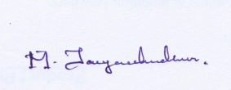

|  |  |
| --- | --- |
| **Dr. M. Jayachandiran** Assistant Professor Event Coordinator  Department of Physics | **Dr.S.Shahil Kirupavathy** Professor & Head Convener  Department of Physics |
|  |  |

### ANNEXURE-I

**Table 1: List of Participants**

|  |  |  |  |  |  |
| --- | --- | --- | --- | --- | --- |
| **Team** | **Name of the Student1** | **Name of the Student2** | **Name of the Student3** | **Branch & Section** | **Title of the Project** |
| 1 | Kavitha V | SarumathiM | LekshmiPriya K | EEE | Plasticwastesintousefulproducts |
| 2 | ThanuShree.N | Shakthi Priya.H | Rowinshia.J | ECE-C | Nanofabrication |
| 3 | T.Vaishnavi | K.Janani | C.S.Abaiambigai | ECE-C | AIingreenenergy |
| 4 | SyedFaiz | Kabilan.S | Nil | ECE-C | AIGreenEnergy |
| 5 | Kaviya.U | SaiDharshini.D | Dharanika.S | ECE-C | Antennatheoryanddesign |
| 6 | B.Madheswari | M.Ramya | H. ShakthiPriya | ECE-C | EnergySource |
| 7 | SivaramVarmaM | Joabus MKumar | SuganthanT | ECE-C | Engineering withsustainability |
| 8 | LokranjanS | KaushikanS | RohithLingamK | ECE-A | Renewableenergy-awaveenergymodel |
| 9 | Charles.S | Balaganesh.R | Monisha.R | MECH | MiniCyclotrons |
| 10 | PrabhaM | OliviaMercyFrancinaJ | JananiPI | AI&DS- A | AIWings- EnhancingtheWind Energy |
| 11 | AjithAnandR | Nil | Nil | ECE-A | InnovationonMobile phoneprocessors |
| 12 | LokeshwaranB | EsakkirajanG | UthayakumarS | MECH | Autonomousbiogasstoragesystem |
| 13 | Devika KG | KavisowmiyaS | Sathyaruba M | AI&DS- A | Engineeringsolutions onglobalwarming |
| 14 | DharanyaaR | NarmathaM | Nil | EEE | SteamTurbineCycle |
| 15 | MugilarasiMS | PrameelaRijalH | ManjushreeK, AishwaryaS | CSE-A | Quantumsensor inmedicalimaging |
| 16 | SidharthR | SandeepR | Nil | CSE-D | travelandtourism |
| 17 | KannanS | Jeeva Prasanna | RoshanRegis | CSE-A | Chooseyour career - ByTeamCuroso |

**Table 2: Ideathon’24 (Final List)**

|  |  |  |  |  |  |  |
| --- | --- | --- | --- | --- | --- | --- |
| **Team** | **Name of the Student1** | **Name of the Student2** | **Name of the Student3** | **Branch & Section** | **Title of the Project** | **Abstract status** |
| 1 | Kavitha V | SarumathiM | LekshmiPriya K | EEE | Plasticwastesintousefulproducts | Accepted |
| 2 | ThanuShree.N | Shakthi Priya.H | Rowinshia.J | ECE-C | Nanofabrication | Accepted |
| 3 | T.Vaishnavi | K.Janani | C.S.Abaiambigai | ECE-C | AIingreenenergy | Accepted |
| 4 | SyedFaiz | Kabilan.S | Nil | ECE-C | AIGreenEnergy | Accepted |
| 5 | Kaviya.U | SaiDharshini.D | Dharanika.S | ECE-C | Antennatheoryanddesign | Accepted |
| 6 | B.Madheswari | M.Ramya | H. ShakthiPriya | ECE-C | EnergySource | Accepted |
| 7 | SivaramVarmaM | Joabus MKumar | SuganthanT | ECE-C | Engineering withsustainability | Accepted |
| 8 | LokranjanS | KaushikanS | RohithLingamK | ECE-A | Renewableenergy-awaveenergymodel | Accepted |
| 9 | Charles.S | Balaganesh.R | Monisha.R | MECH | MiniCyclotrons | Accepted |
| 10 | PrabhaM | OliviaMercyFrancinaJ | JananiPI | AI&DS- A | AIWings- EnhancingtheWind Energy | Accepted |
| 11 | AjithAnandR | Nil | Nil | ECE-A | InnovationonMobile phoneprocessors | Accepted |
| 12 | LokeshwaranB | EsakkirajanG | UthayakumarS | MECH | Autonomousbiogasstoragesystem | Accepted |
| 13 | Devika KG | KavisowmiyaS | Sathyaruba M | AI&DS- A | Engineeringsolutions onglobalwarming | Accepted |
| 14 | DharanyaaR | NarmathaM | Nil | EEE | SteamTurbineCycle | Accepted |
| 15 | MugilarasiMS | PrameelaRijalH | ManjushreeK, AishwaryaS | CSE-A | Quantumsensor inmedicalimaging | Accepted |
| 16 | SidharthR | SandeepR | Nil | CSE-D | travelandtourism | Accepted |
| 17 | KannanS | Jeeva Prasanna | RoshanRegis | CSE-A | Chooseyour career - ByTeamCuroso | Accepted |

### ANNEXURE –II (BROUCHER, REGISTRATION FORM)

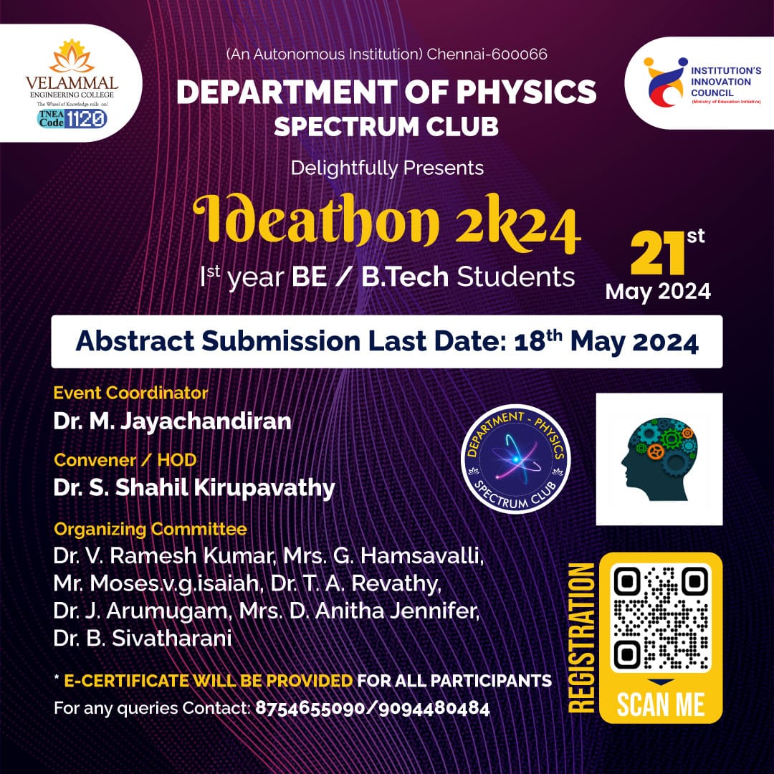

*Figure 1: Poster for Ideathon’24*

**Registration form link :** [***https://forms.gle/KskESiS98idJGEBD6***](https://forms.gle/KskESiS98idJGEBD6)

**ANNEXURE –III**

**Photographs**

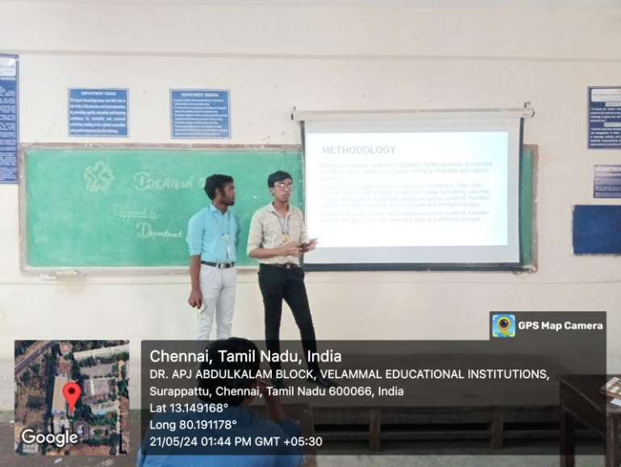

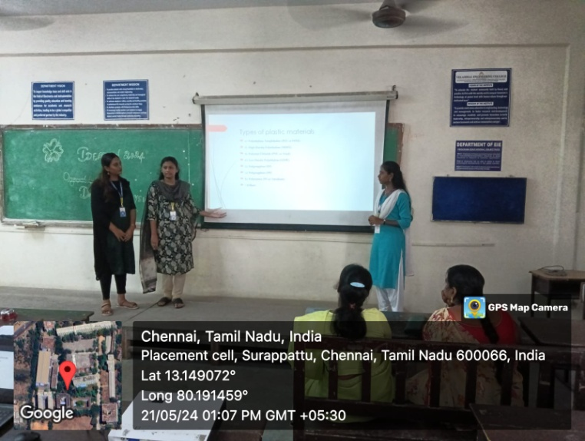

*Figure 2: Students are presented the idea on the event Ideathon’24*

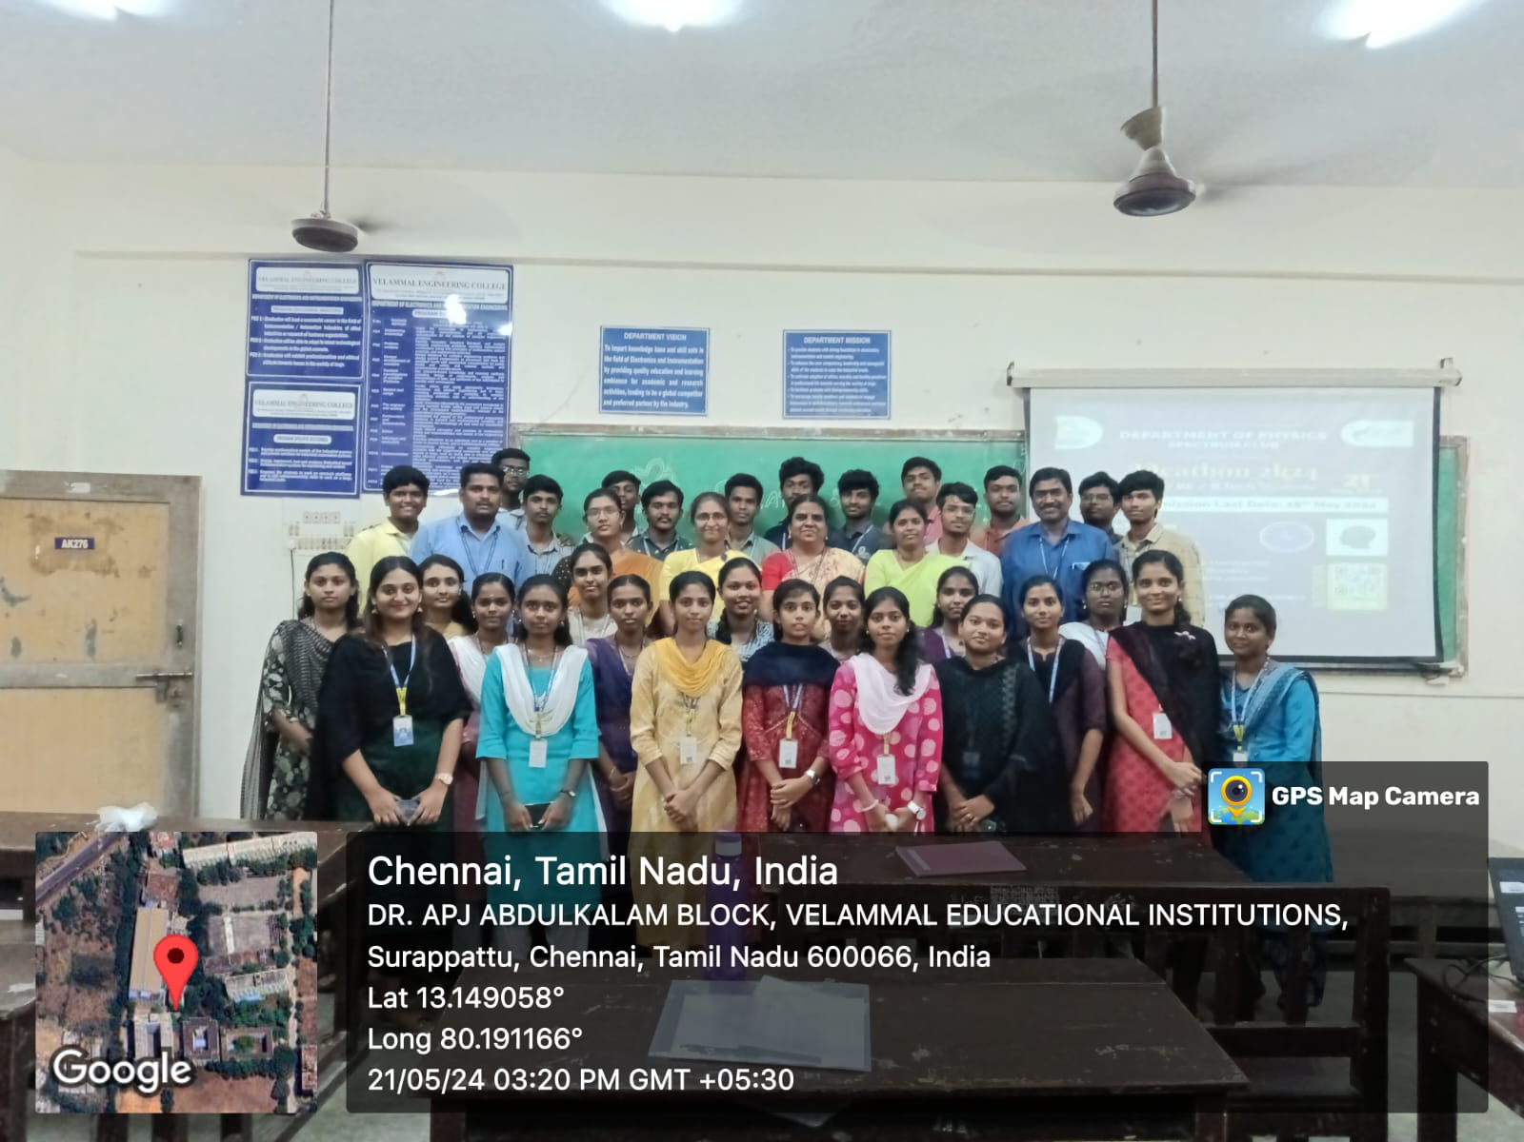

*Figure 3: Group photo session at the end of the event Ideathon’24.*

**ANNEXURE –IV**

**Table 3: Participants Feedback**

|  |  |  |
| --- | --- | --- |
| **Sl.No** | **NAME** | **How was the Ideathon’24?** |
| 1 | SarumathiM | Very Useful |
| 2 | Shakthi Priya.H | Talent show case platform |
| 3 | K.Janani | Informative |
| 4 | Kabilan.S | Excellent |
| 5 | SaiDharshini.D | Superb |
| 6 | M.Ramya | Helpful for future |
| 7 | Joabus MKumar | Inculcating research |
| 8 | KaushikanS | Good |
| 9 | Balaganesh.R | Excellent |
| 10 | OliviaMercyFrancinaJ | Encourage Research ideas |